24. C A N A D A

Talk about – rozprávajte o:
- General information – všeobecné informácie:
  - Location + population – poloha + obyvateľstvo
  - Geography – geografia, zemepis
  - Climate - podnebie
  - Industry & agricalture – priemysel a doprava
  - Political system + education – politický systém + vzdelávanie
- Places of interest in Canada + the capital city/Ottawa/ – zaujímavé miesta v Kanade + hlavné mesto
- People & their customs + traditions – ľudia a ich zvyky + tradície

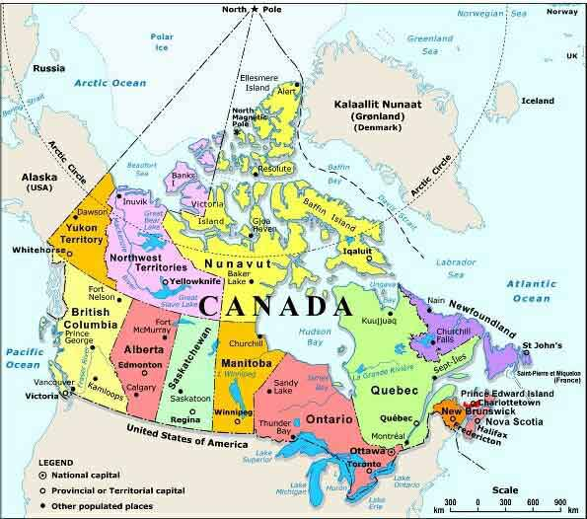

1. General information:
Canada is the 2nd largest country in the world (after Russia) => it’s area is 9, 984 670 km².
It has the population of about 32 million people => the majority is of European origin, the North American Indians, Eskimos… => Canada is less crowded than the USA.
The name “Canada” is of Indian origin and means “village” or “settlement”. (kanata = village).
The currency is 1 Canadian dollar which is divided into 100 cents.
The official languages are English and French. The capital city is Ottawa.
Canada is an independent federation within the Commonwealth. It is divided into:
- 10 provinces
- 2 territories

GEOGRAPHY:
Canada borders on /hraničí s/:
- NORTH – sever => the Arctic ocean
- SOUTH – juh => the USA
- EAST – východ => the Atlantic ocean
- WEST – západ => the Pacific ocean and Alaska (USA)

MOUNTAINS /hory/ and LOWLANDS /nížiny/:
Western part of Canada, which is called the Cordillera, is very mountainous and rocky => there are the Rocky Mountains, the Coast Mountains and other ranges. The highest peak of Canada is Mount Logan (5959m) – it is in Yukon. In the east there are the Appalachian mountains but there are also many lowlands. In Canada, there are also large prairies suitable for agriculture.

RIVERS /rieky/ and LAKES /jazerá/:
The most important RIVERS are:
- the Winnipeg River
- the Saskatchewan River
- the St. Lawrence River – Rieka Sv. Vavrinca
- the Columbia River
- the Mackenzie River – the longest river in Canada

The biggest LAKES:
- Great Bear Lake
- Great Slave Lake
- Lake Winnipeg
There are also other great lakes which Canada shares with the USA – Lake Huron, Lake Erie, Lake Ontario, Lake Superior.
NIAGARA FALLS /Niagarské vodopády/ - the most famous water falls in the world – they lie on the Niagara river, which connects lake Erie and lake Ontario => they are made of American falls (which belong to the USA) and the Horseshoe Falls (which belong to Canada).

Climate
The most inhabited parts of Canada have continental climate – summers are hot and winters are cold. In the north, the climate is arctic.

Industry /priemysel/ & agriculture /poľnohospodárstvo/
Canada is rich in raw materials /nerastné bohatstvo/ - e.g. uranium, gold, zinc, silver, nickel... => mining industry /banícky priemysel/
Canada has many forests – 1/3 of the country is covered with forest and wood industry is very important for them => Canada is a great exporter of wood and wood products.
Canada also belongs to the countries leading in agriculture – wheat (pšenica), maple syrup (javorový sirup) is a typical Canadian product.

Political system
Canada is a constitutional monarchy, a federal state and parliamentary democracy within the British Commonwealth. The head of the state is the Queen Elizabeth II. and the head of the government is the Canadian Prime Minister (premiér).
Canada has 2 official languages and 2 systems of law:
- Civil law – občianske právo
- Common law – zvykové právo
Parliament is responsible for national defence /národná obrana/, international trade /medzinárodný obchod/, immigration /prisťahovalectvo/, criminal law /zákon o kriminalite/…
The regional or provincial legislatures are responsible for education, civil rights /občianske práva/, the hospital system, health care and social security /sociálne dávky/ within their boundaries.

The Canadian system of education /systém vzdelávania/
The system of education in Canada is the responsibility of the 10 provinces and the 2 territories. Public education is free until the children finish the secondary education. Further (post-secondary) education is usually paid – the students pay a tuition /= poplatok/. The school attendance is compulsory from the age of 6 or 7 until they are 15 or 16 years old.
In general, high school programs are divided into 2 parts:
- Preparation for university
- Post-secondary education – at a college or an institute of technology, preparation for a workplace

Places of interest in Canada:

Ottawa – the capital city
The capital city is a business and technological centre of Canada – many big technological companies have their residence there – for example Alcatel. You can visit about 30 museums, 50 galleries, many night clubs and theatres => The National Gallery of Canada, Ottawa Little Theatre, Canadian Museum of Civilization and so on, Ottawa International Jazz festival.

Toronto
Toronto is the biggest city in Canada. It is a city of ethnic minorities. If you want to see the tallest building in the world today, you should travel to this city => there we can find the Canadian National Tower (CN Tower) – it is visited by about 2 million people every year because it is an excellent place for observation and it offers a beautiful view. There is a revolving restaurant in it.
The Toronto ZOO – the ZOO is divided into geographical regions and you can see there more than 5000 animals in their natural environment.

Canadian National Parks
Canada is famous for its beautiful nature, especially the forests. Parks are located across entire Canada and there are many protected plans and species of animals. There are many parks that are a big attraction to tourists – for example Jasper National Park, Glacier National Park, Fundy National Park, Terra Nova National Park, St. Lawrence Islands National Park, Greenwich, Prince Albert National Park

Quebec – Montreal
Montreal is the second biggest city in Canada, the biggest city in the province Quebec. It is a French speaking city. La Ronde is the biggest amusement park in Montreal => the Montreal Fireworks Festival is held there every summer. Tourists often visit also the Old Montrea, which is the historical part of the city – there is the Old port.

People and their customs and traditions
In the USA people celebrate these national holidays:
- Christmas
- Easter
- Thanksgiving Day - 2nd Monday in October
- Remembrance Day - dedicated to the soldiers killed in the WW I. & WW II.

Canadian people are very good at playing hockey – they have won many national competitions and cups. Other sports played in Canada are for example basketball, golf and so on.
Canadian people are friendly and Canada is a good country for newcomers. It is a multicultural country – it is home to a large number of aboriginal people, called First Nations. Over the past century and a half, Canada has welcomed 15 million immigrants. Every year about 200,000 new immigrants arrive here => Canada has a national policy for multiculturalism and people's customs and traditions here are preserved and respected.

Vocabulary:

the majority – väčšina
origin – pôvod
mean – znamenať
settlement – osídlenie
currency – mena
independent – nezávislý
within – v, v rámci
Commonwealth – názov spoločenstva, ktoré združuje bývalé Britské kolónie
border on – hraničiť s
mountainous – hornatý
rocky – skalnatý
range – pohorie, pásmo hôr, chrbát hôr
peak – vrchol
lowlands – nížiny
prairie – préria
suitable for – vhodný na
share – deliť sa (o niečo)
water falls – vodopády
lie – ležať
connect – spojiť
belong to – patriť (niekomu)
ihabited – osídlený
forest – les
wood industry – lesnícky priemysel
lead in – viesť v niečom
leading in – vedúci v
government - vláda
law – zákon
responsible for – zodpovedný za
regional legislature - regionálna legislatíva
boundaries – hranice
the responsibility – zodpovednosť
public education – verejné vzdelávanie
until – až kým
school attendance – školská dochádzka
compulsory – povinná
in general – vo všeobecnosti
college – odborná škola
preparation – príprava
residence – sídlo
ethnic minorities – etnické menšiny
you should – mal by si
find – nájsť
observation – pozorovanie
a revolving restaurant – otáčajúca sa reštaurácia
divide – rozdeliť
locate – umiestniť
across – krížom cez
entire – celý
protected – chránený
species of animals – druhy zvierat
amusement park – zábavný park
firework – ohňostroj
celebrate – oslavovať
Thanksgiving Day – Deň Vďakyvzdania
Remembrance Day – Pamätný (Spomienkový) Deň
dedicate - venovať
soldier – vojak
competition – súťaž
newcomer – prisťahovalec
multicultural country – multikultúrna krajina
over the past century – počas minulého storočia
welcome – privítať
arrive – prísť
national policy – národná politika
customs – zvyky
preserve – zachovať

